**Real Time Project 3:**- **3 tier** based application on **AWS** using Terraform / Course Completion ✔ **Practical 29** :- **40** AWS Resource / services (EC2 + VPC + ELB + Autoscaling + RDS + EIP + Subnet etcccc) creation on AWS with Terraform i.e. via Infrastructure as a Code approach.

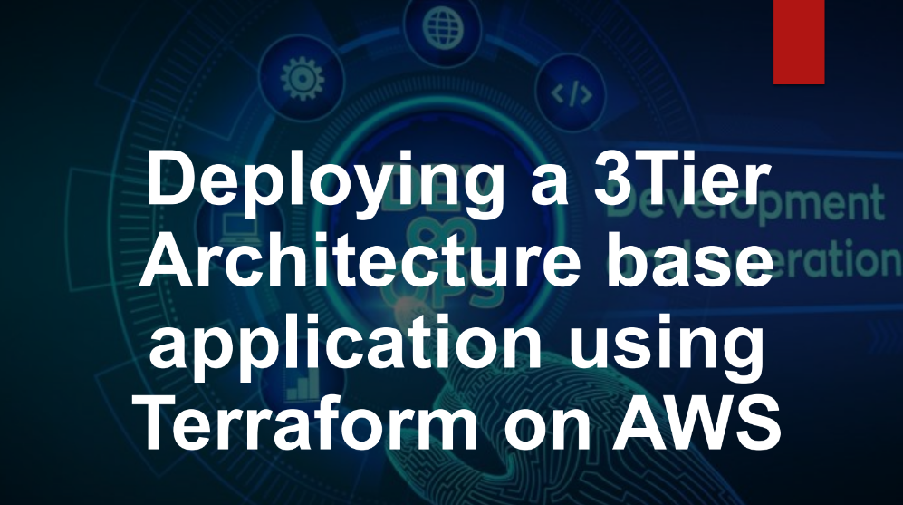

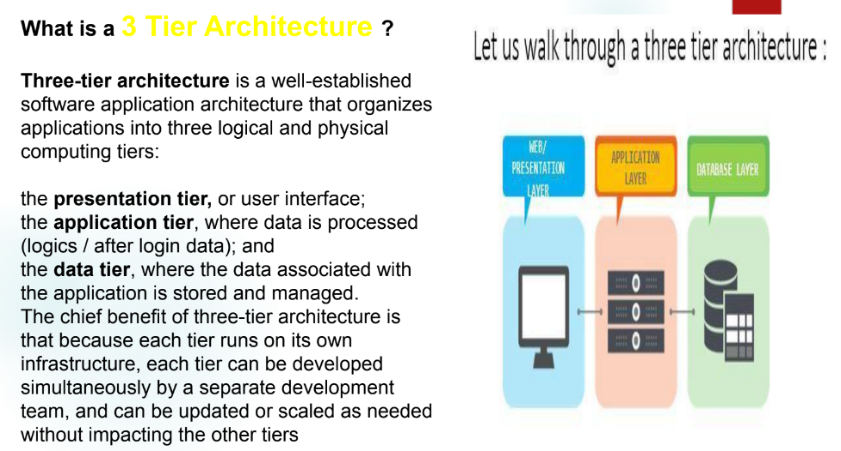

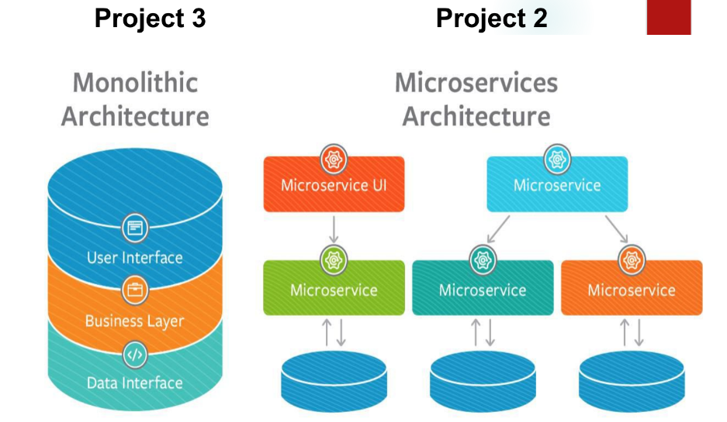

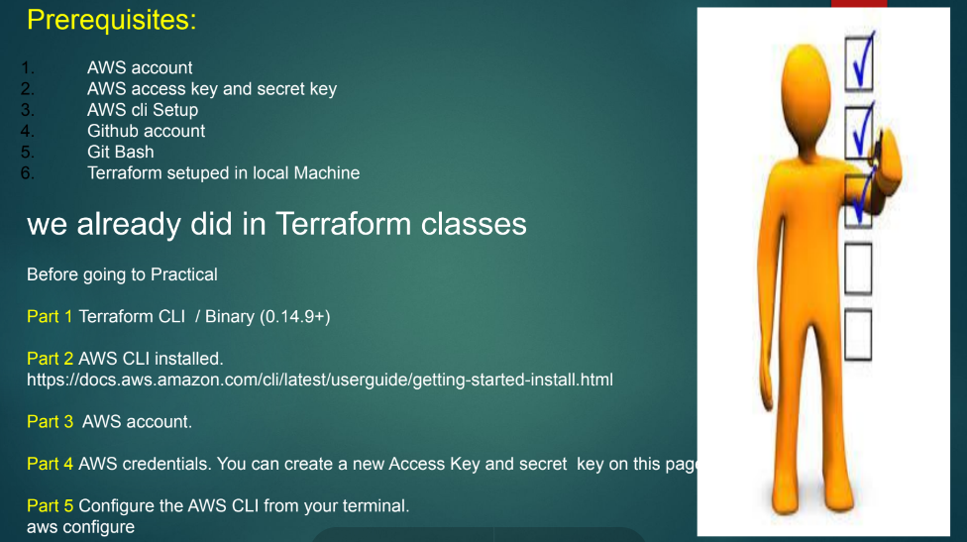

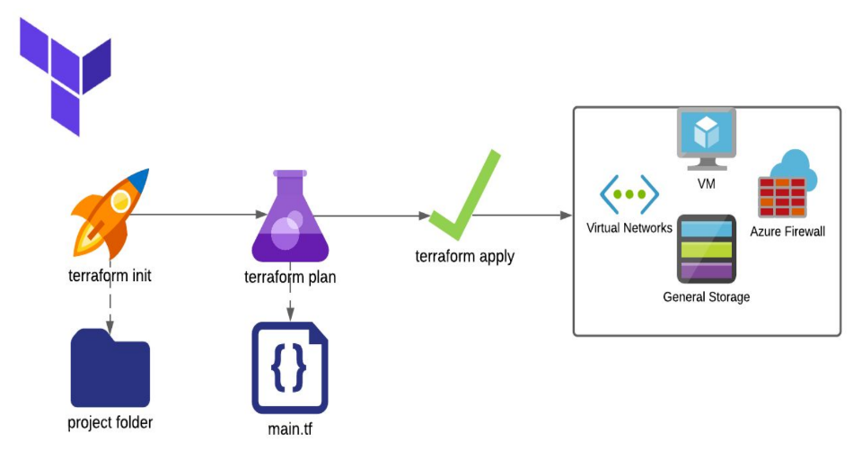

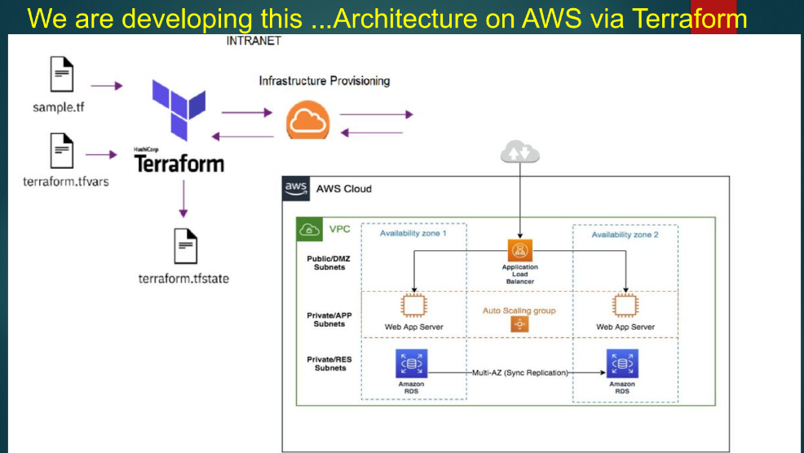

GitHub: <https://github.com/DevSecOpsG/3-tier-architecture>

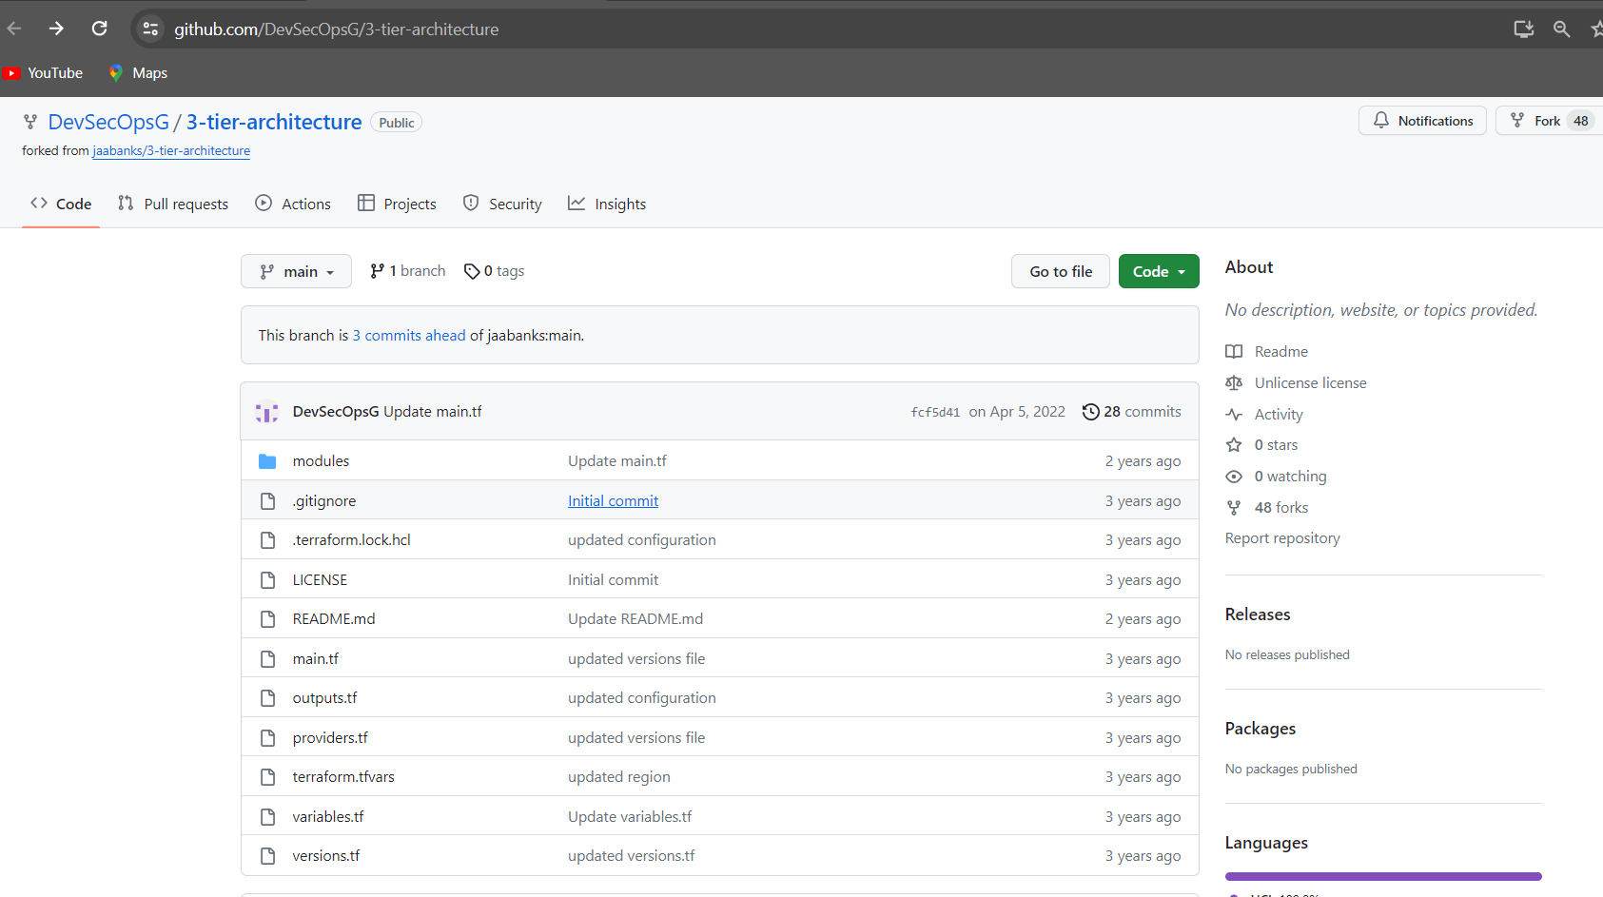

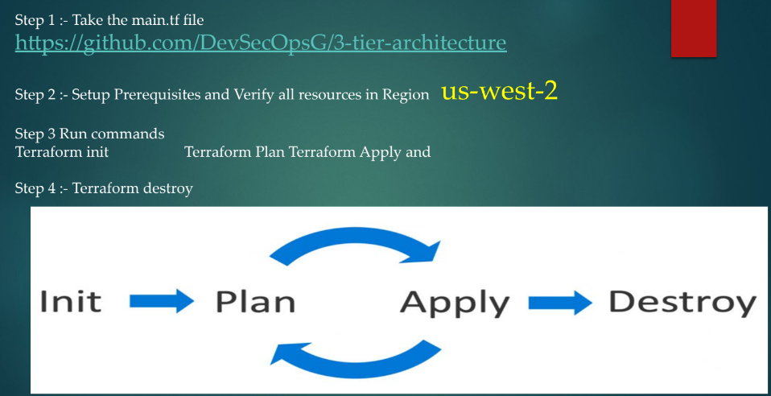

* You can check it by google <https://registry.terraform.io/providers/hashicorp/aws/latest/docs>

In Below this part as I highlighted are in this above github account (providers.tf)

provider "aws" {

region = var.region

}

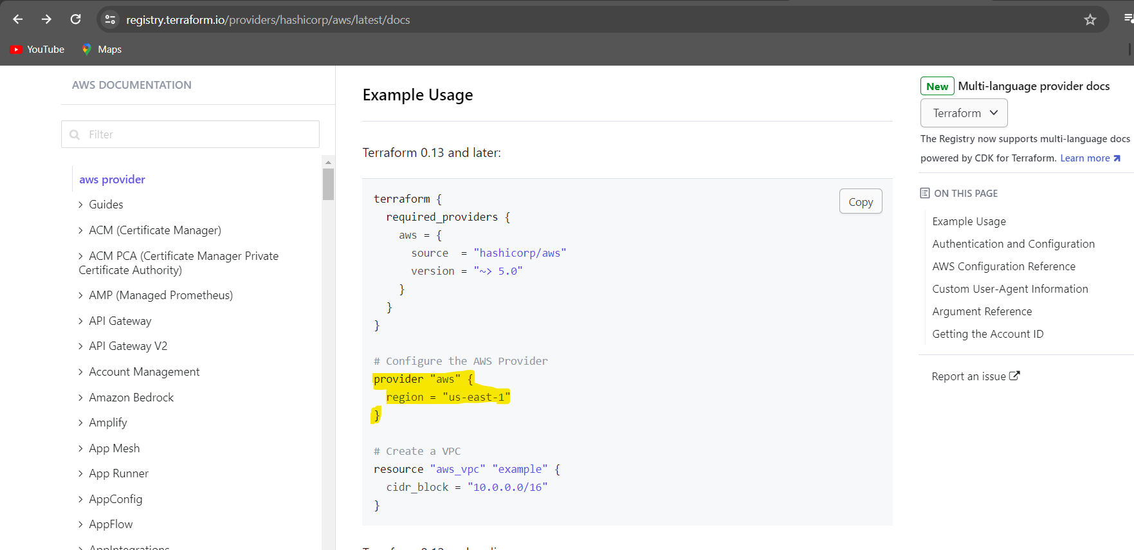

Same thing version in also you can check it by google as I mentioned below attached snapshot. (versions.tf)

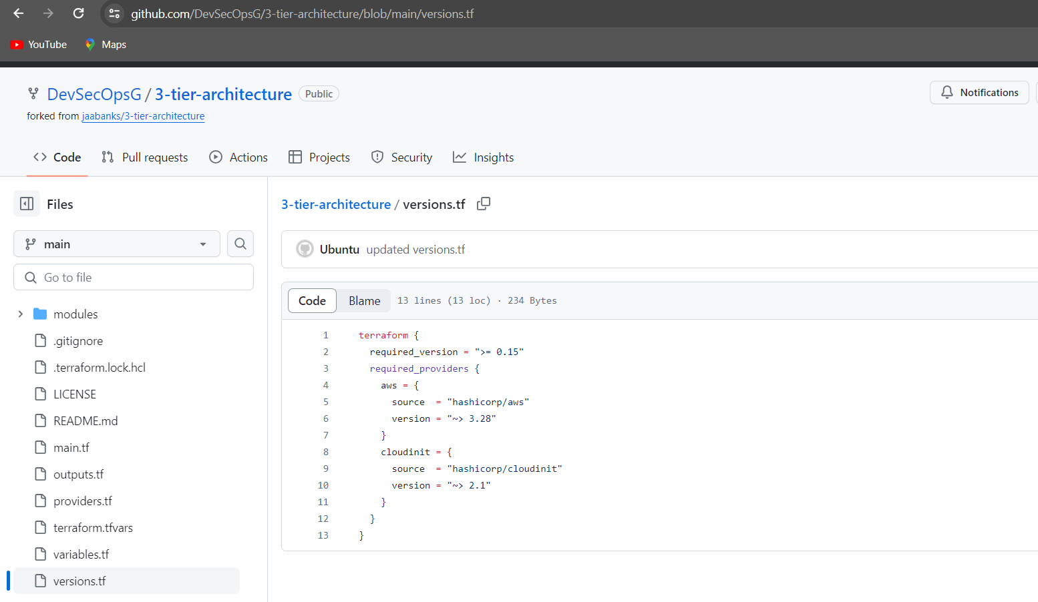

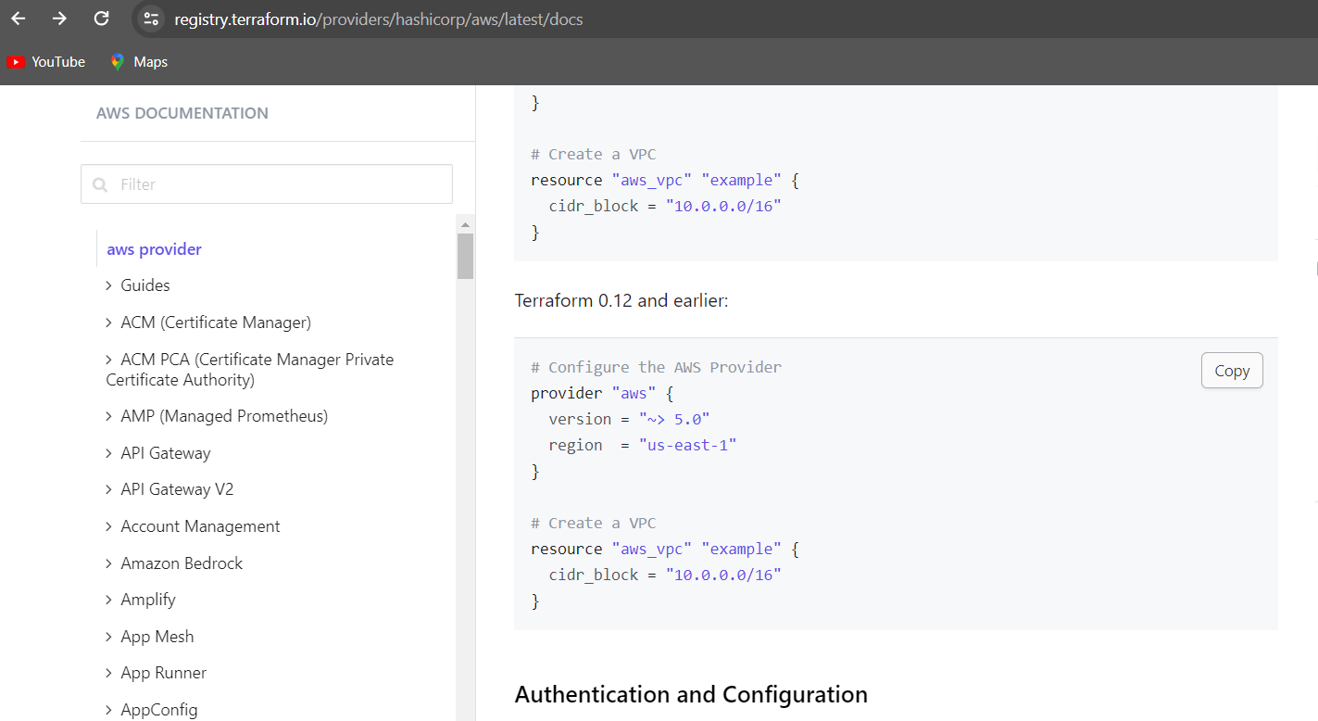

Whatever any changes need you can edit your github account, same type of all services in github

Copy this code: <https://github.com/DevSecOpsG/3-tier-architecture.git>

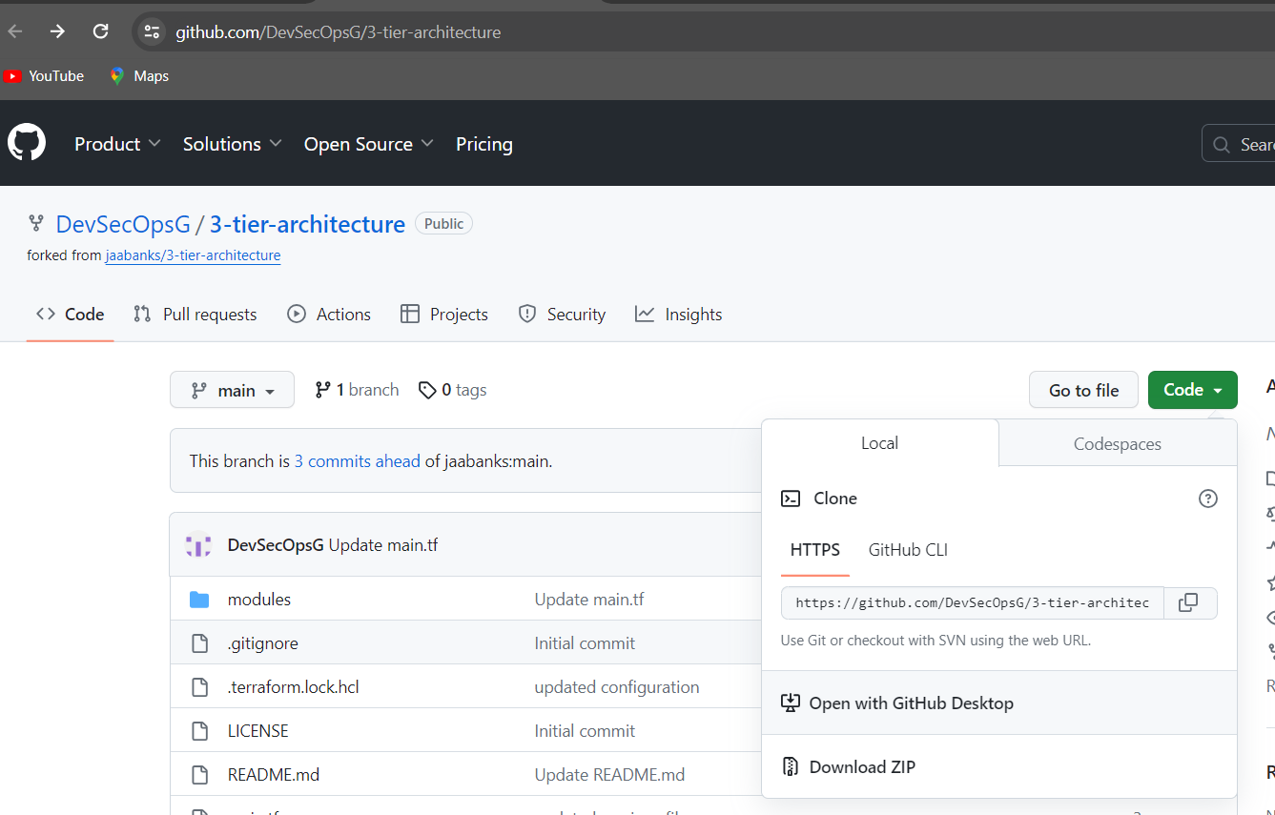

Then go to your local environment and open Git Bash

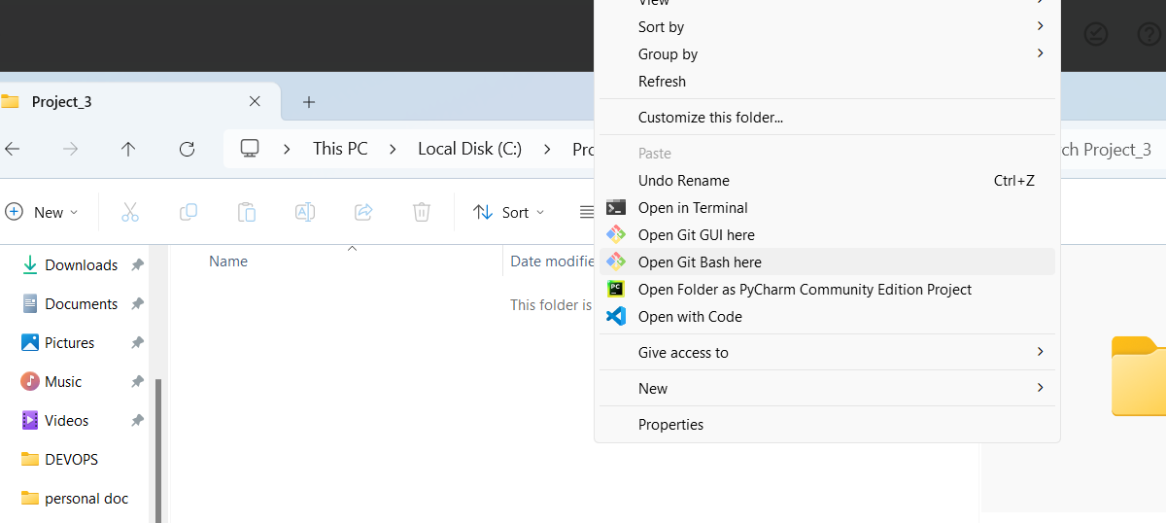

Then in your git bash type it: “git clone <https://github.com/DevSecOpsG/3-tier-architecture.git>”

One folder has been created in your local

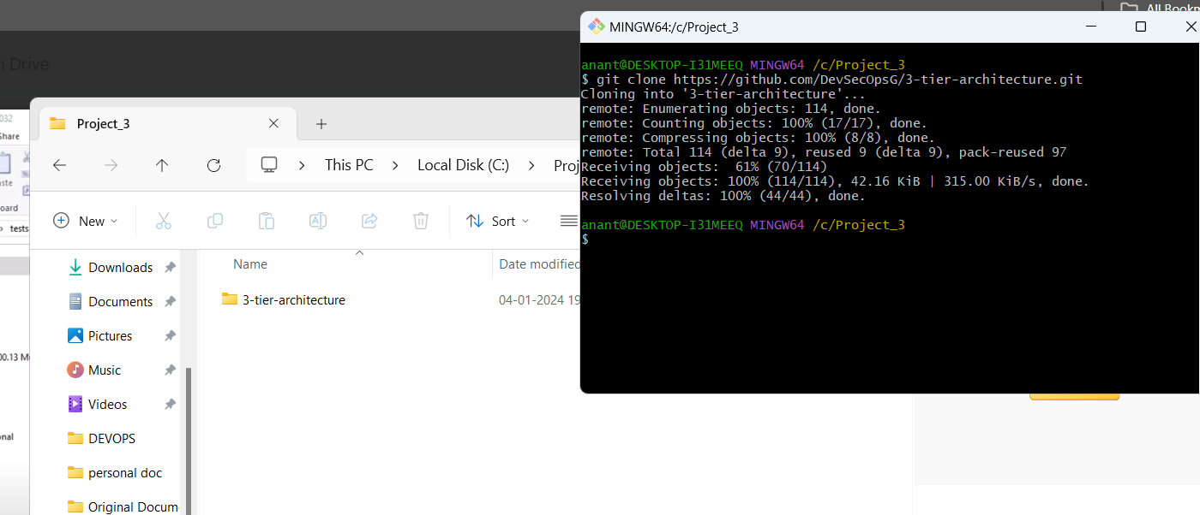

Type command in gitbash:

ls

cd 3-tier-architecture/

ls

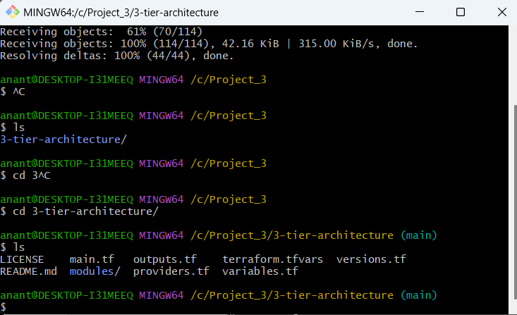

Now I am opening this folder by VS code

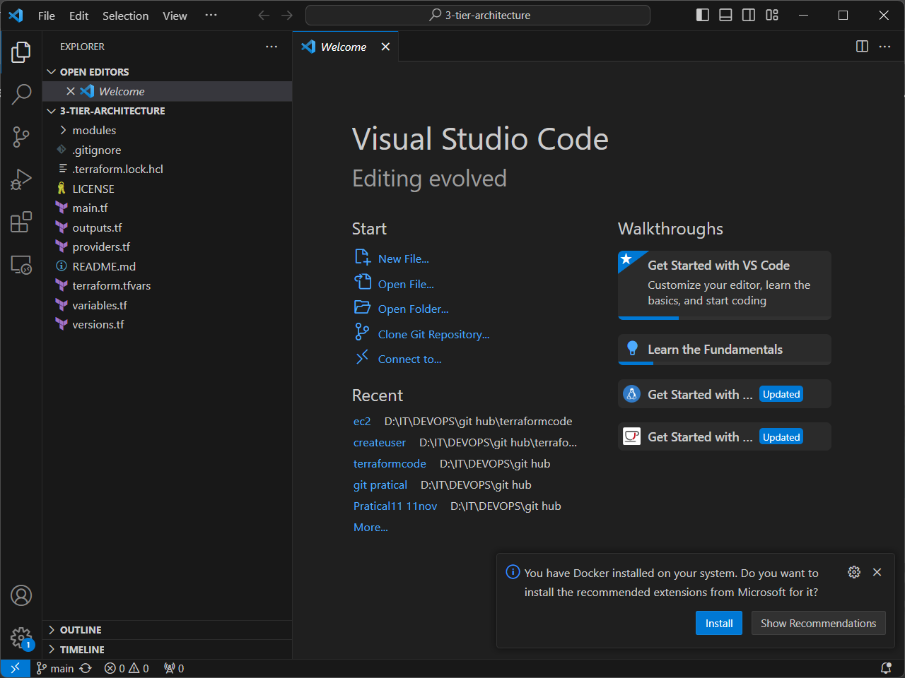

As soon as the “terraform init” command it will execute and three modules, dependencies are getting download it my environment, it will come into the .terraform folder

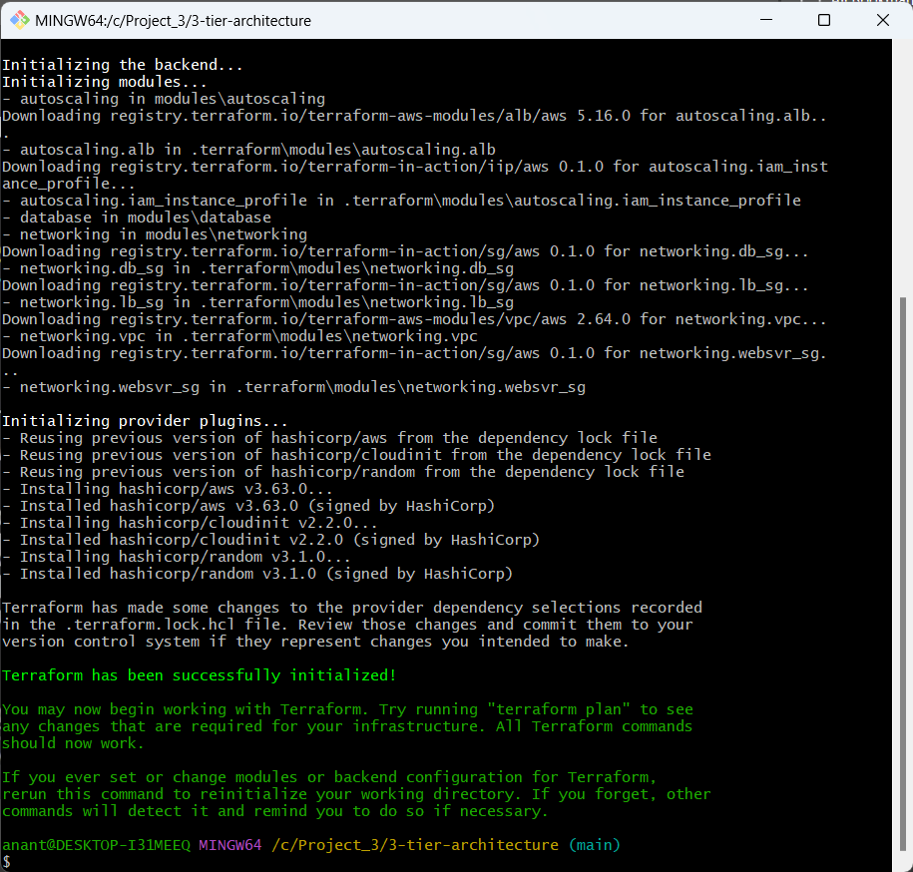

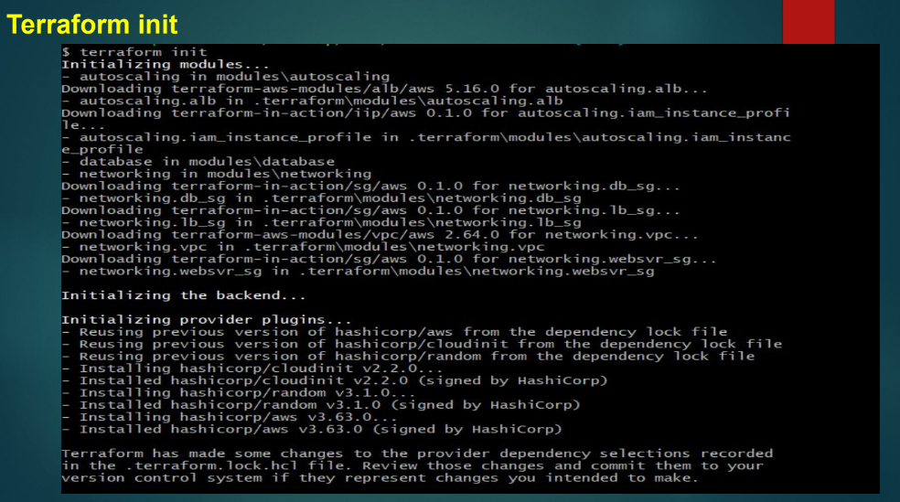

Then you have go to “terraform plan”

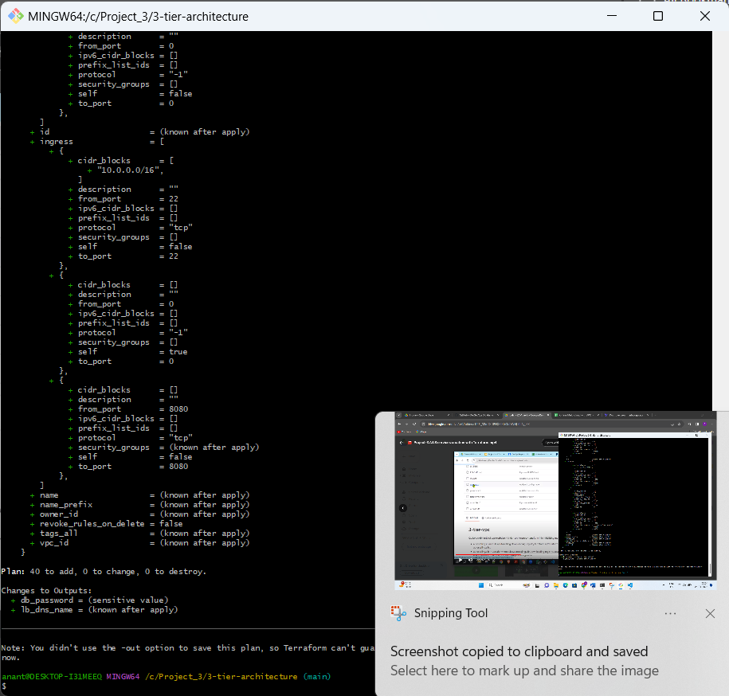

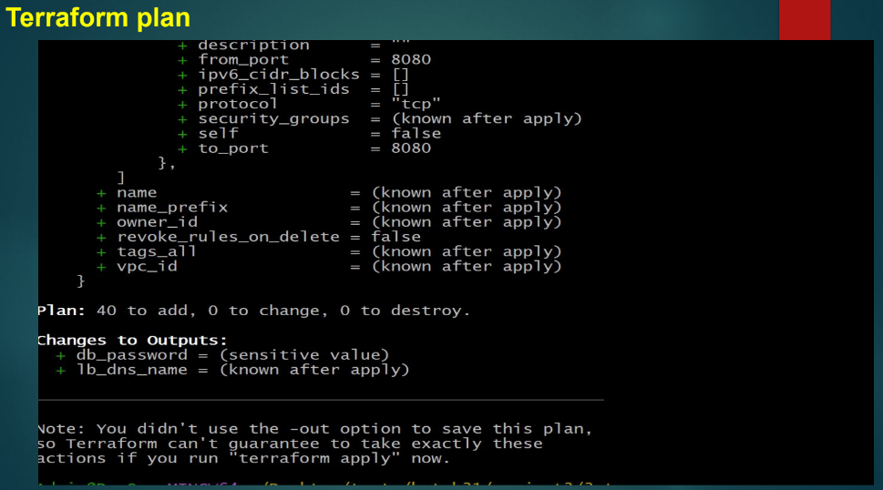

Then go to your aws account and check it your region

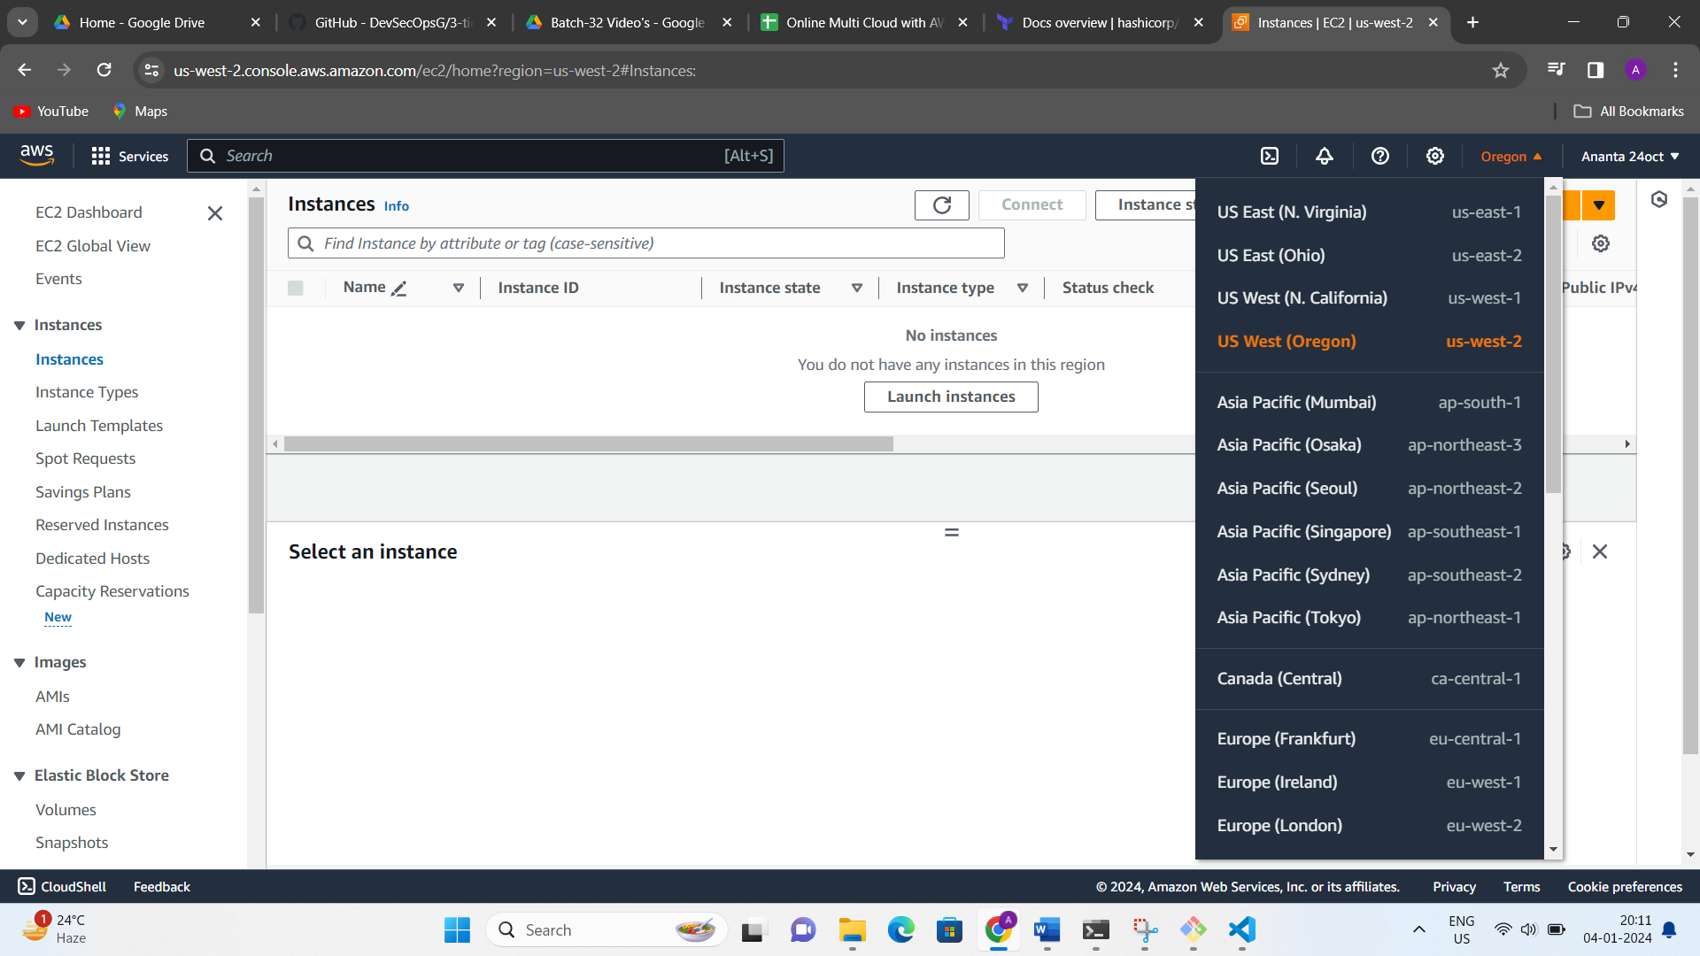

Then you check it in your aws services aren’t in three tier link (instances,RDS, vpc, subnets, Natgateway, Routetable, security groups,instances, IAM, Loadbalancer,auto scaling, Elastic Ips, ….)

Then type command : “terraform apply”

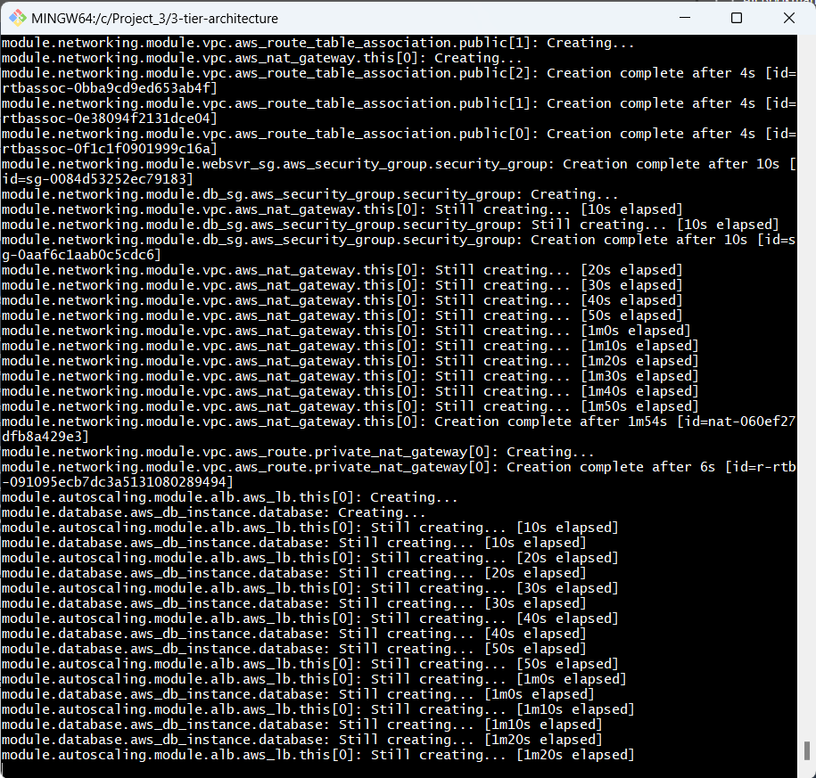

You check it in your aws vpc , it has been created my-3-tier-architecture-vpc

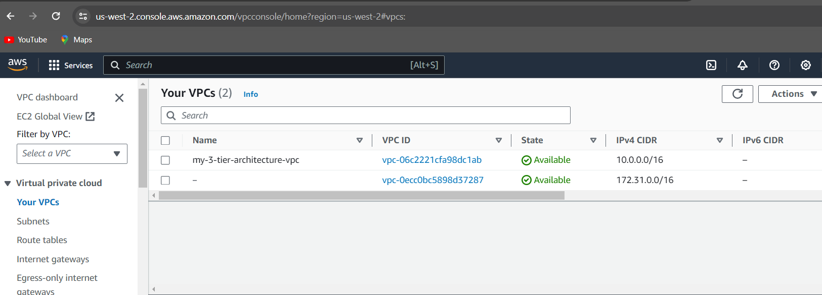

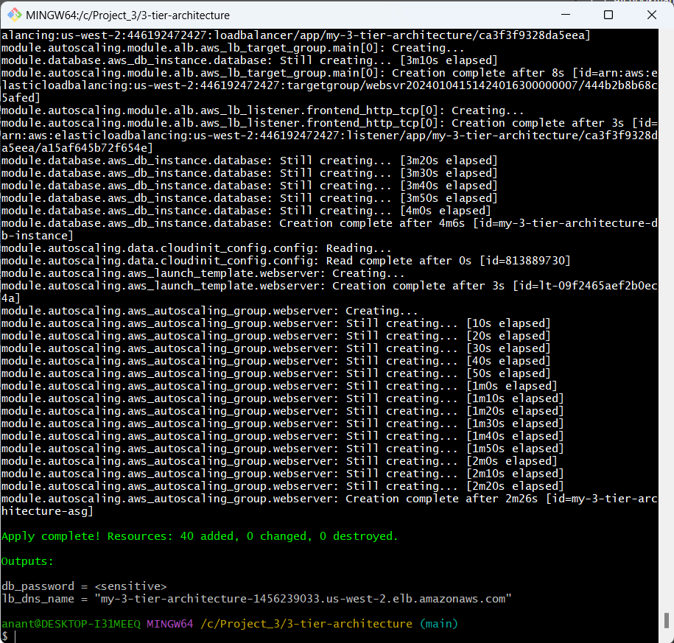

Then you check it in load balancers and copy this DNS name and paste it browser

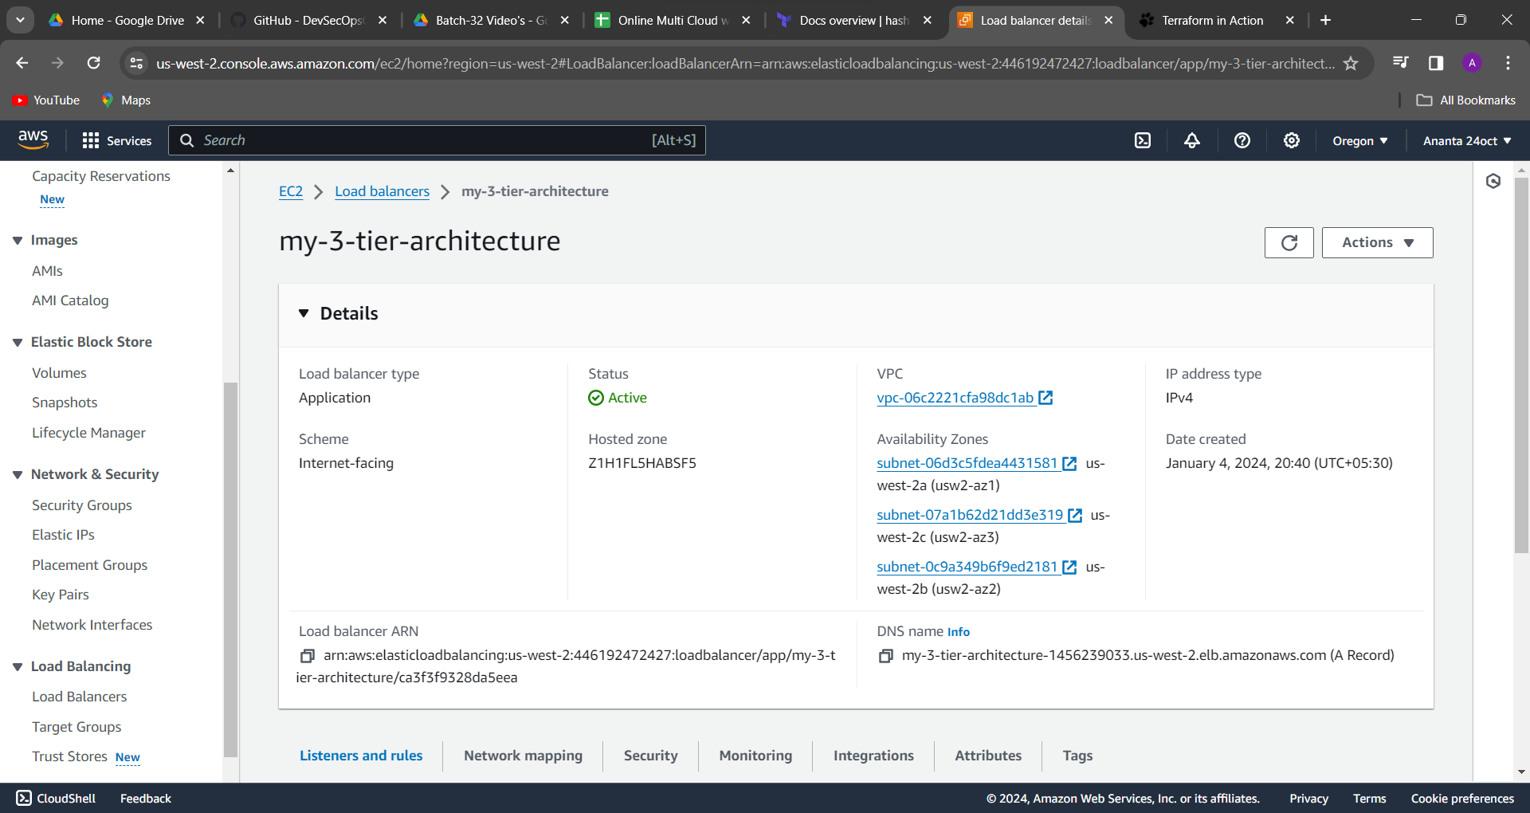

my-3-tier-architecture-1456239033.us-west-2.elb.amazonaws.com

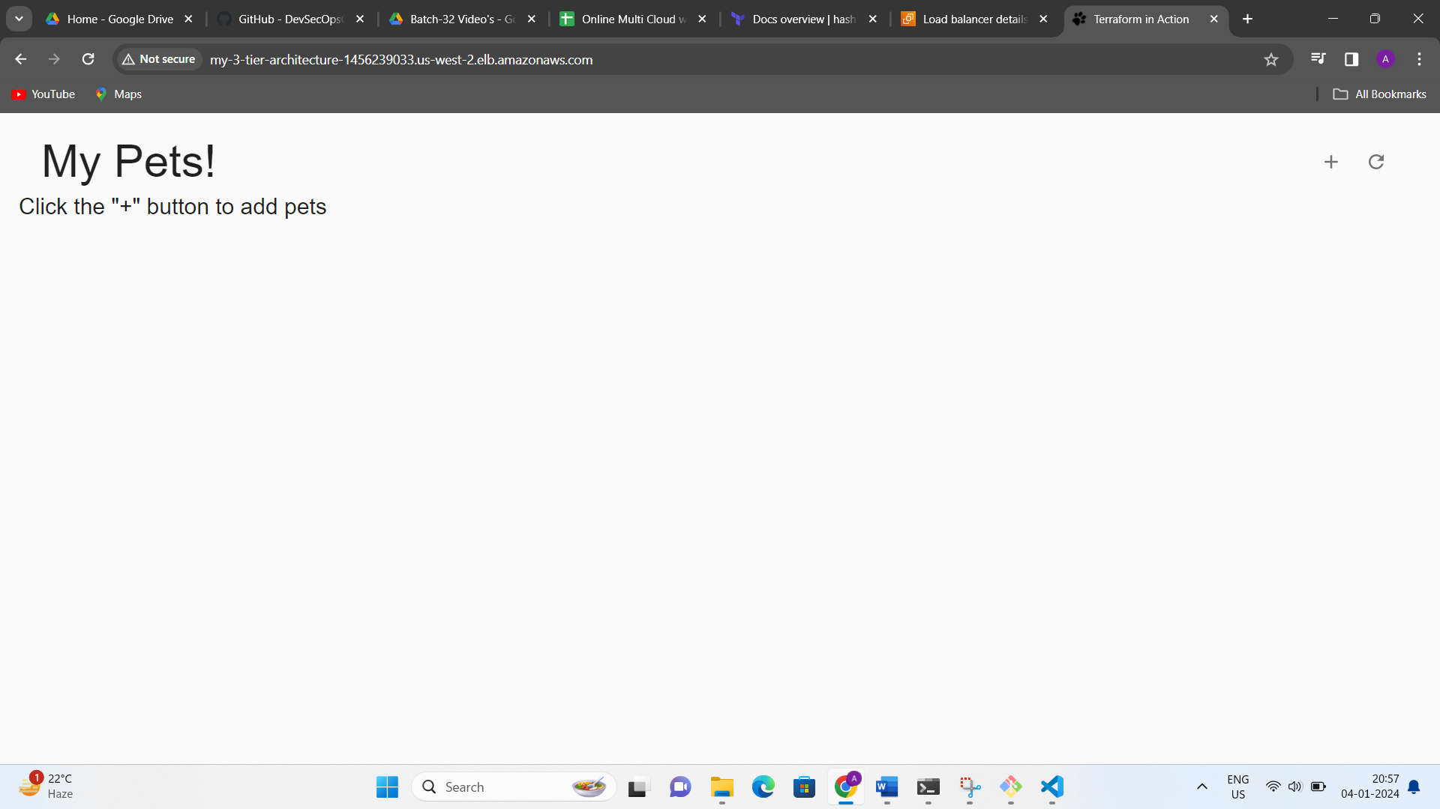

This is the fronted application and you click on this + sign option and you some data fill

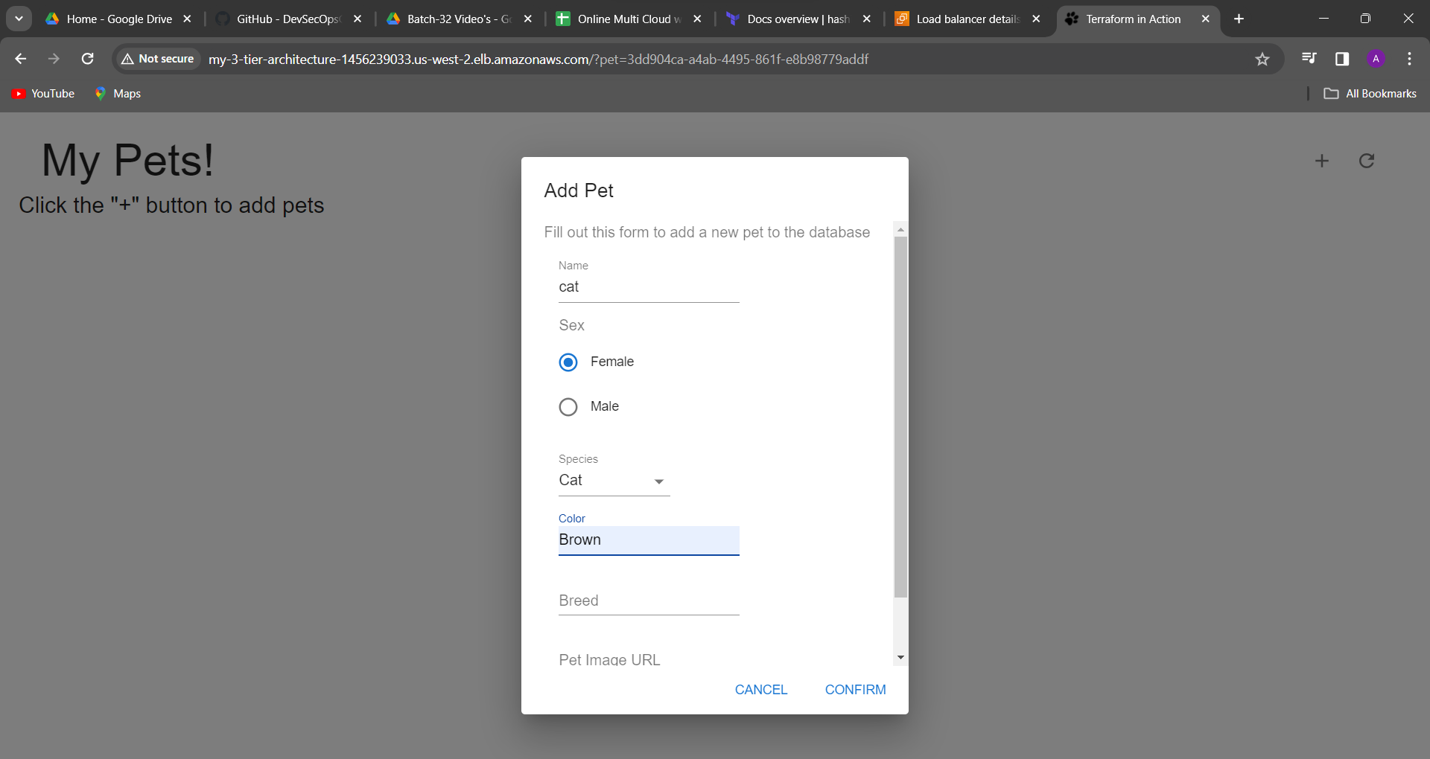

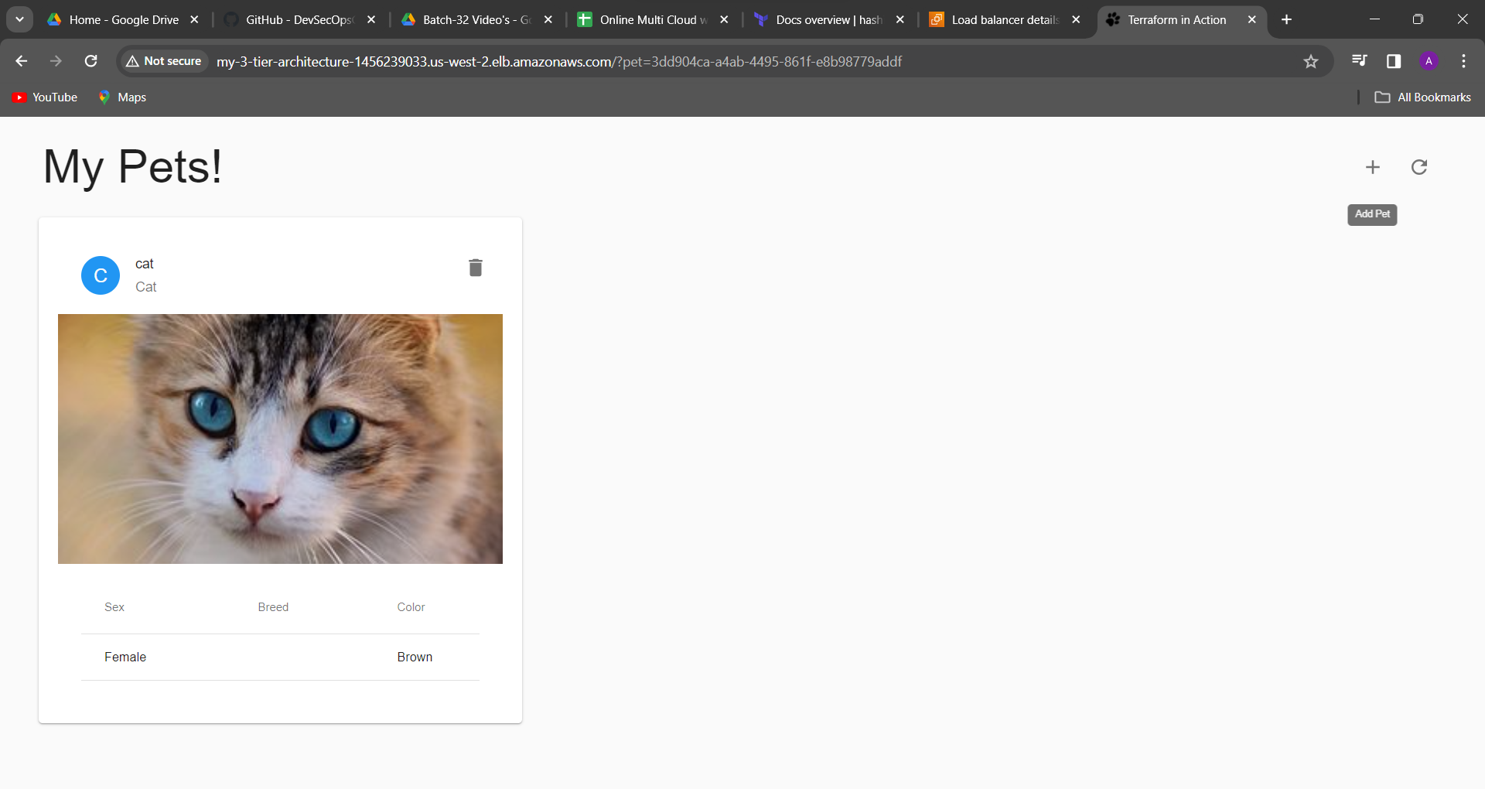

This cat image come backend in your databases loaded.

Q. If your application UI is working

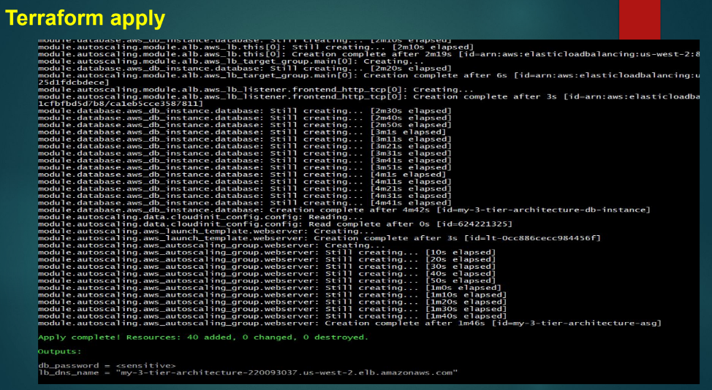

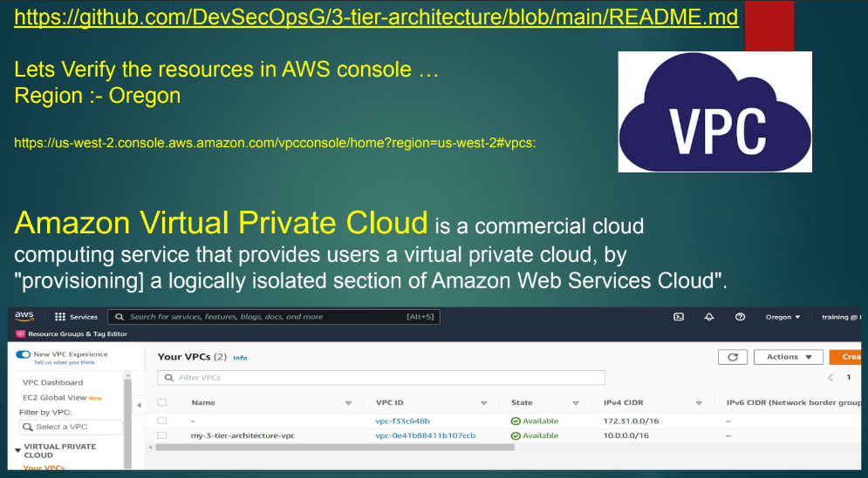

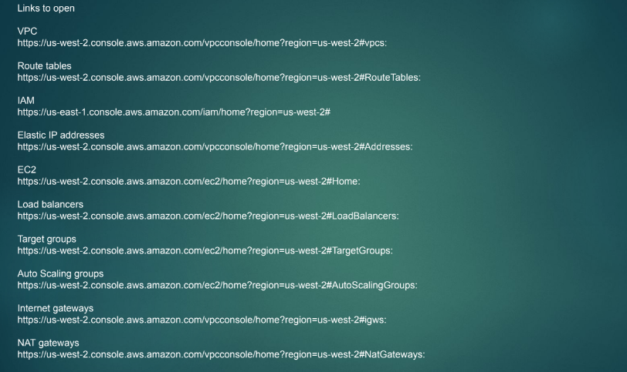

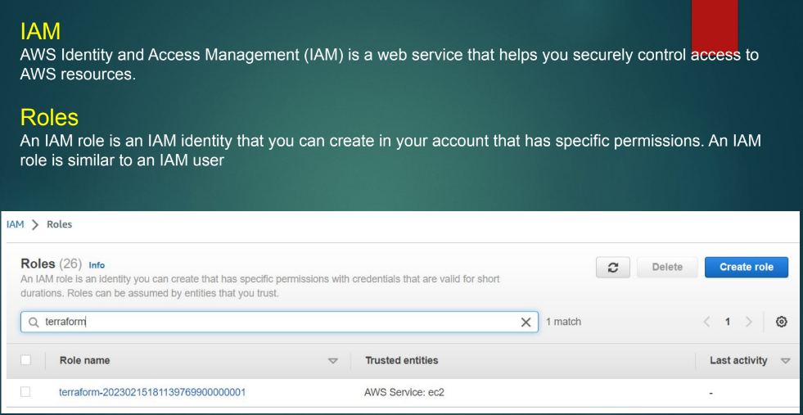

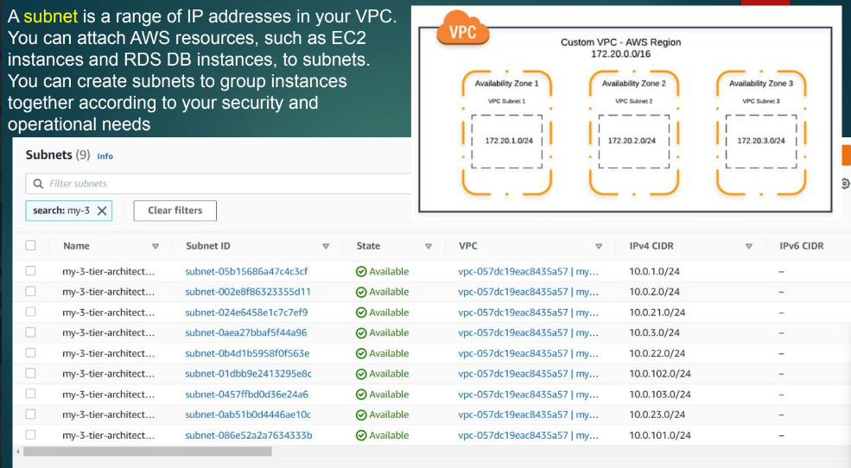

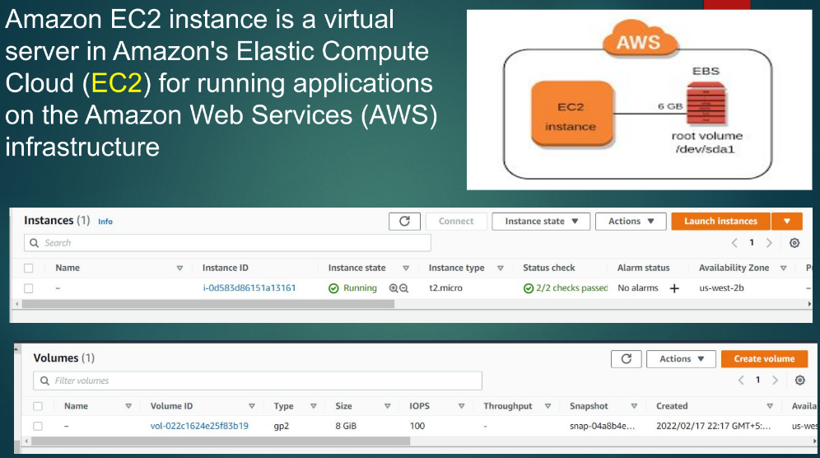

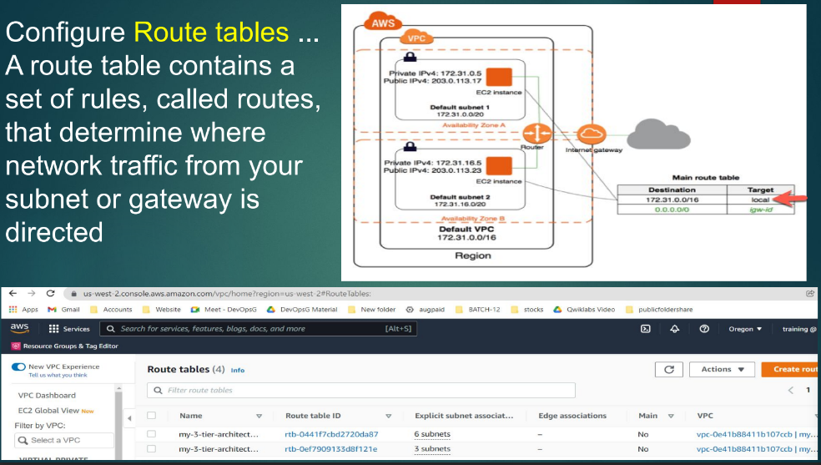

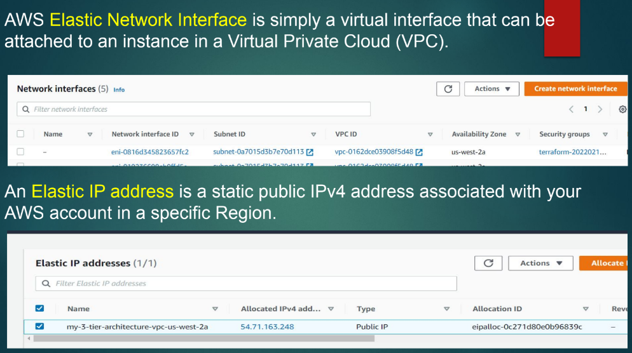

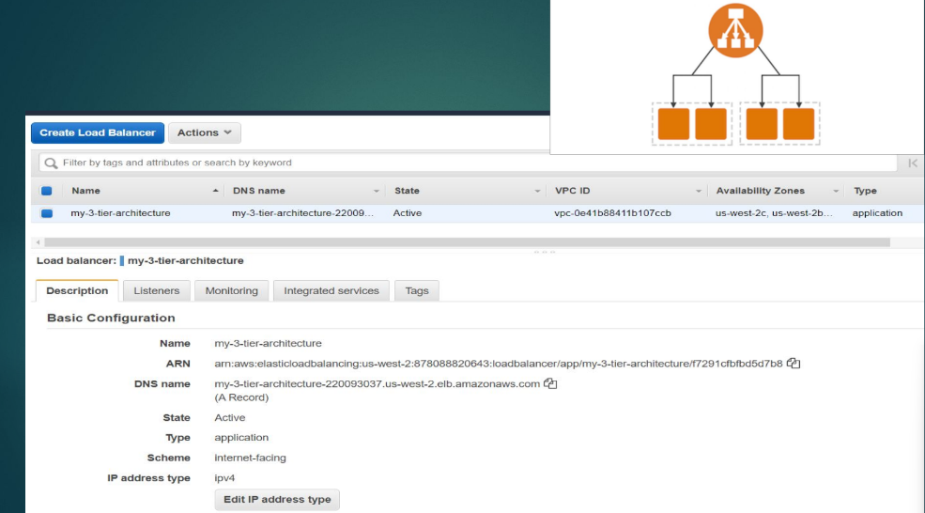

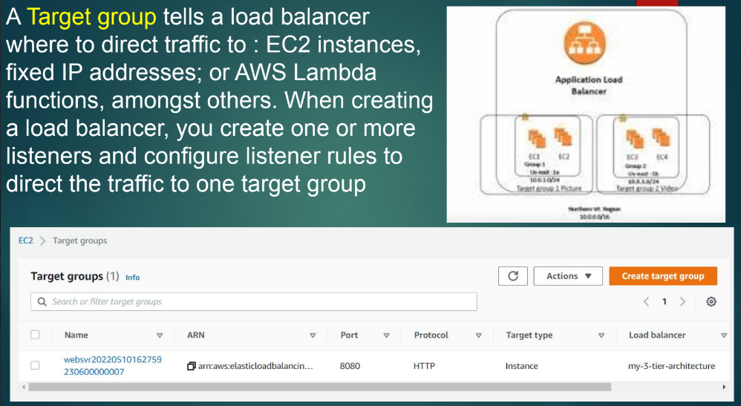

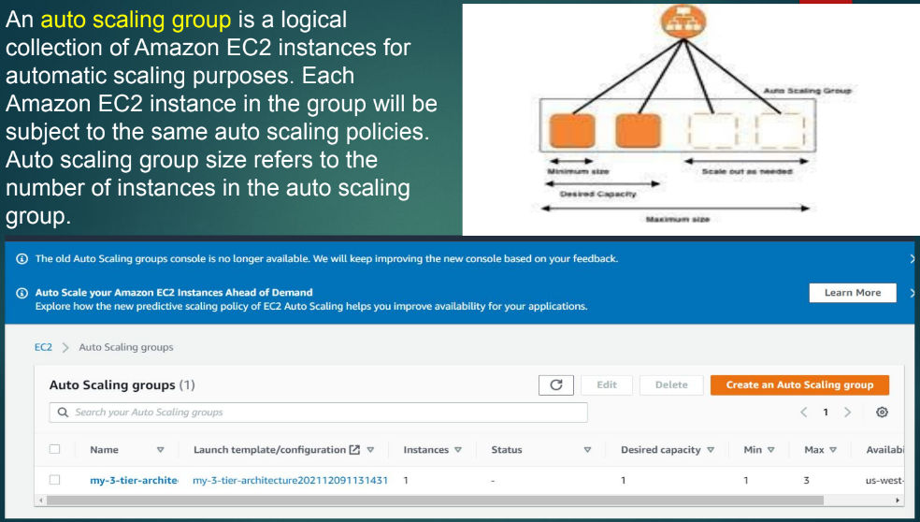

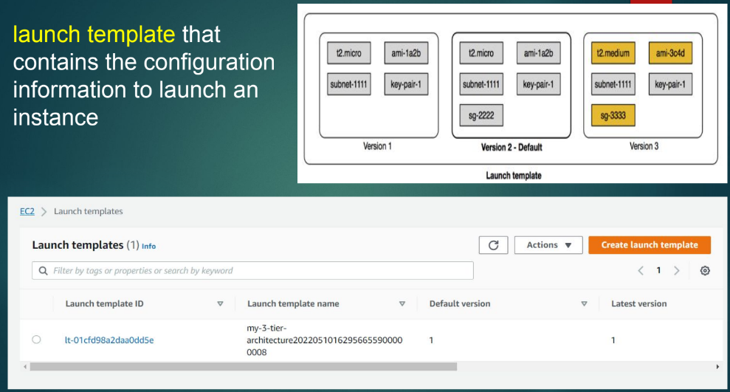

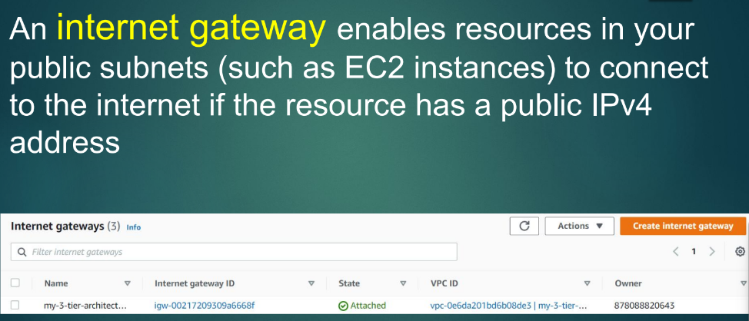

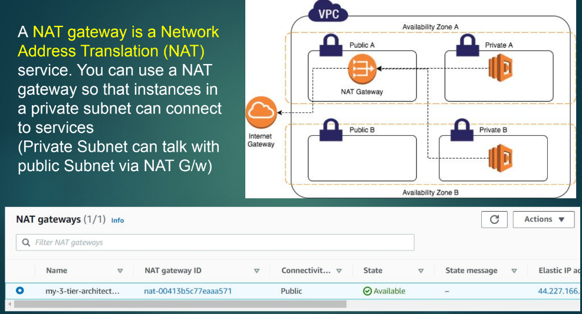

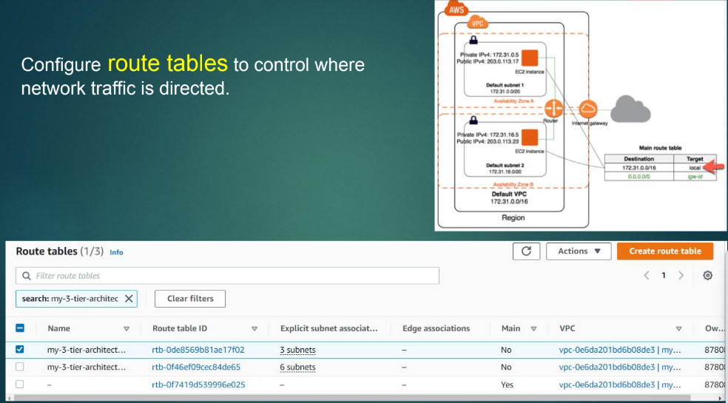

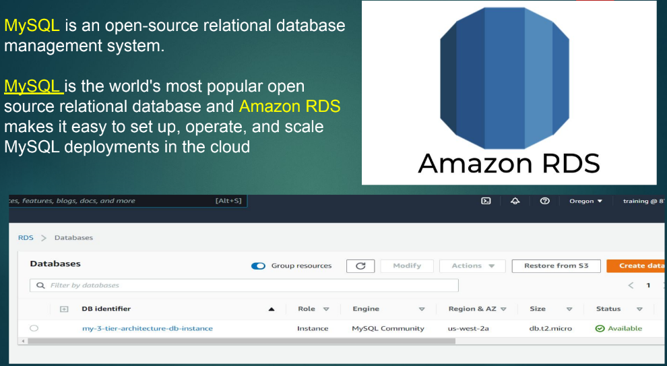

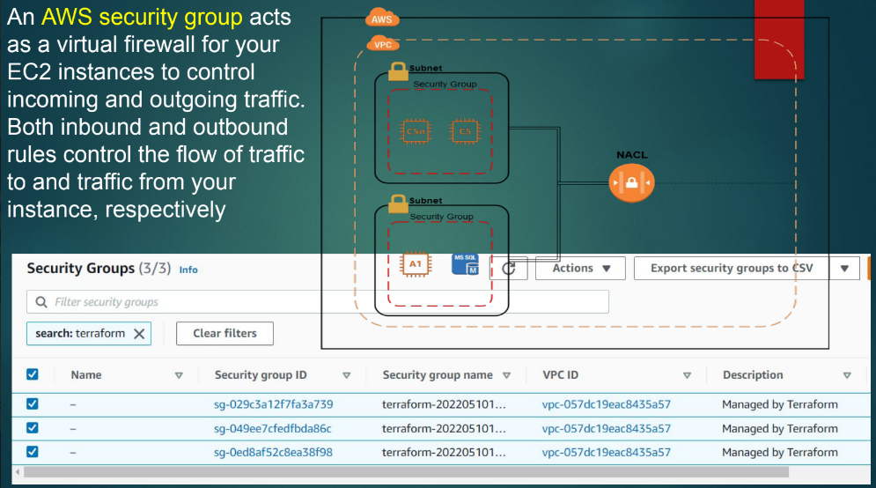

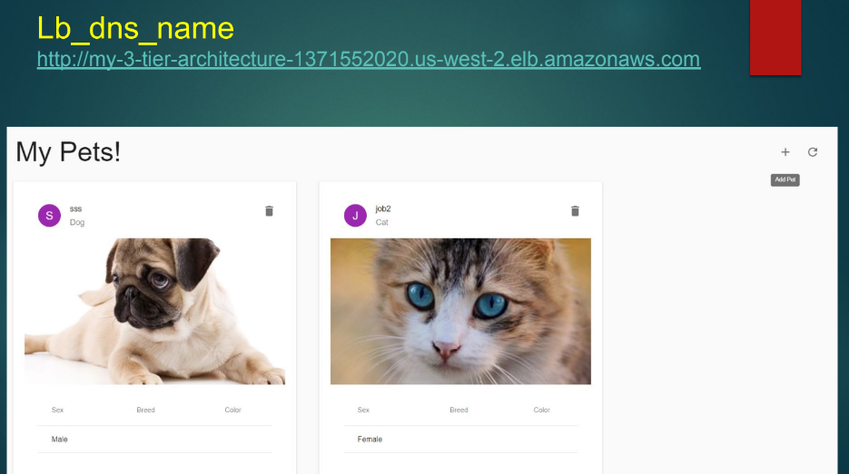

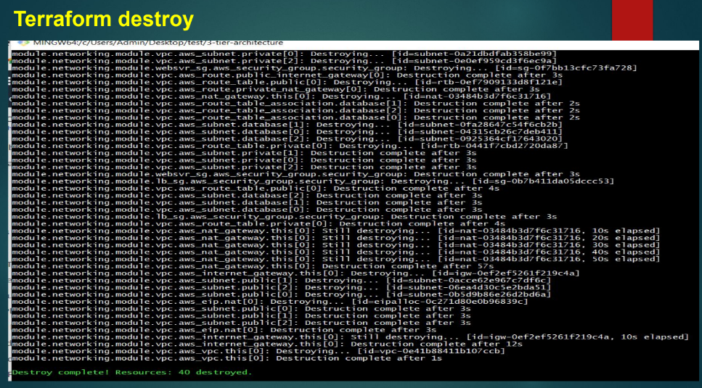

Then you must have to type it command : terraform destroy

